Matthew Young

IT450

Lab 3 – Advanced Wireshark

1a. they repeatedly reset and reconnected to the server to gain permission to create a new user, once they got in as a guest user through Anonymous Authentication they then ran an FTP attack on the root user/password.

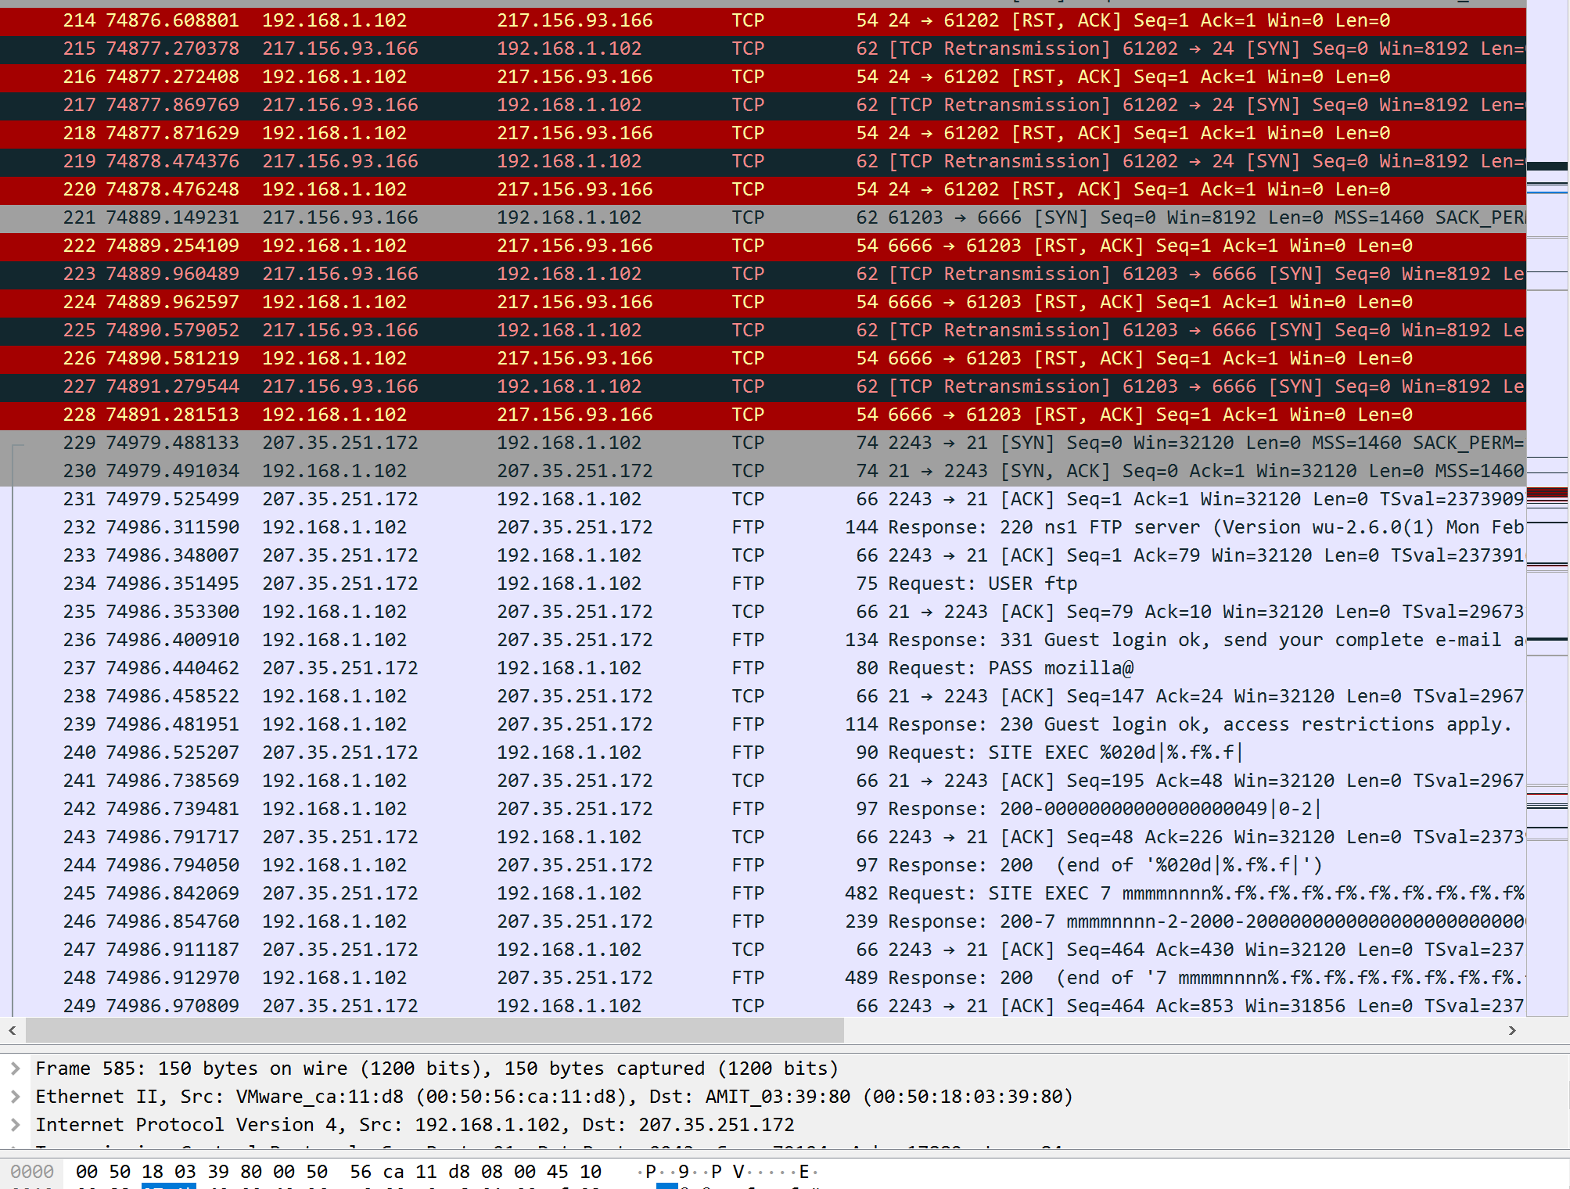

1b. Packet No. 240

1c. Packet No. 416

2. they looked in directories, searched through them using ls, accessed specific files in certain directories, created new files, created a user, and installed some software.

3. Zer0.tar.gz ||| copy.tar.gz ||| ooty.tar.gz

4a. port 22

4b. Client: Telnet Operating system: Red Hat Linux release 6.2

